Web Service Structure :

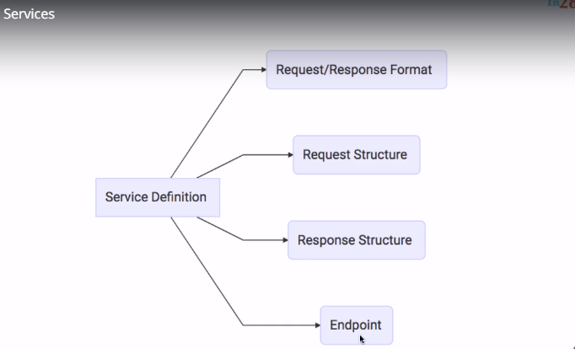

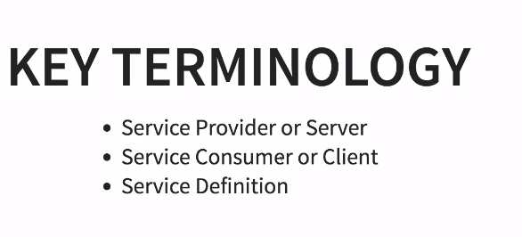

Soap Web Services :

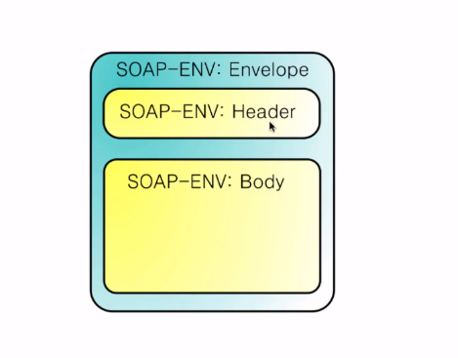

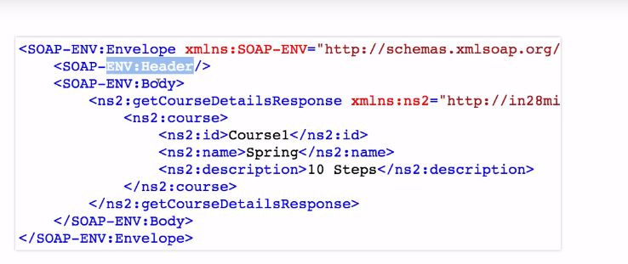

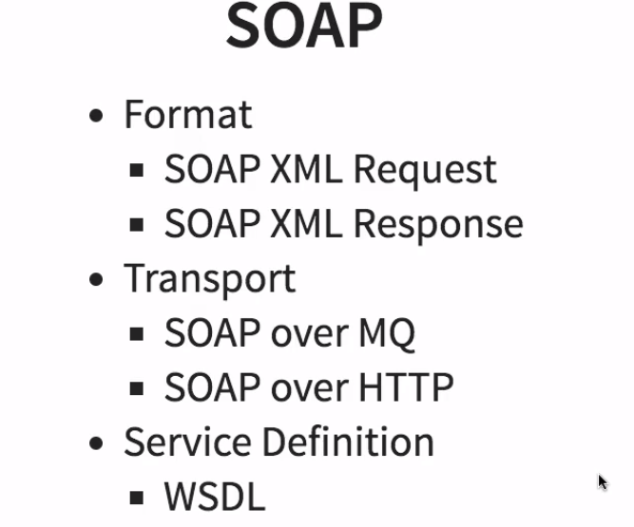

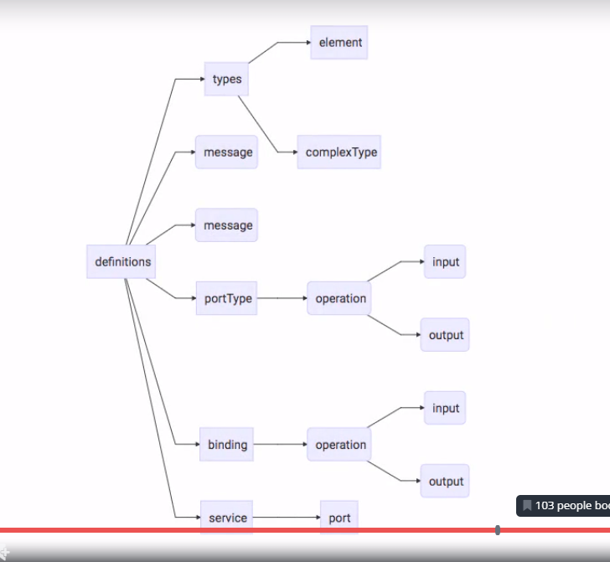

Rest full Web Service :

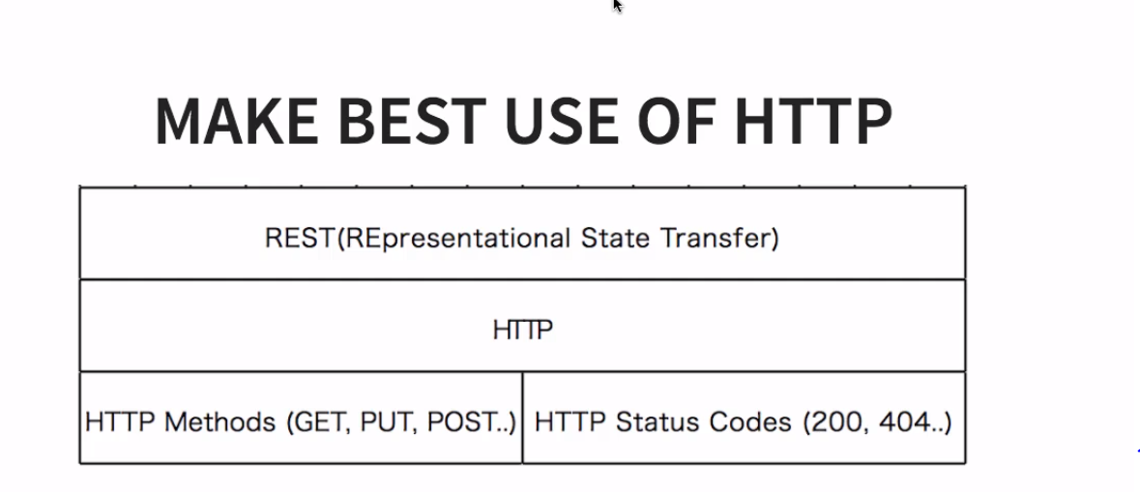

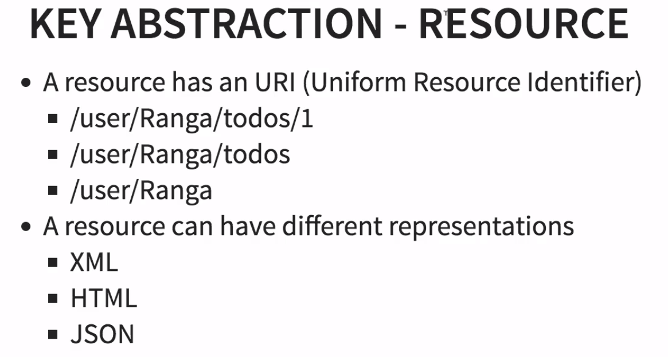

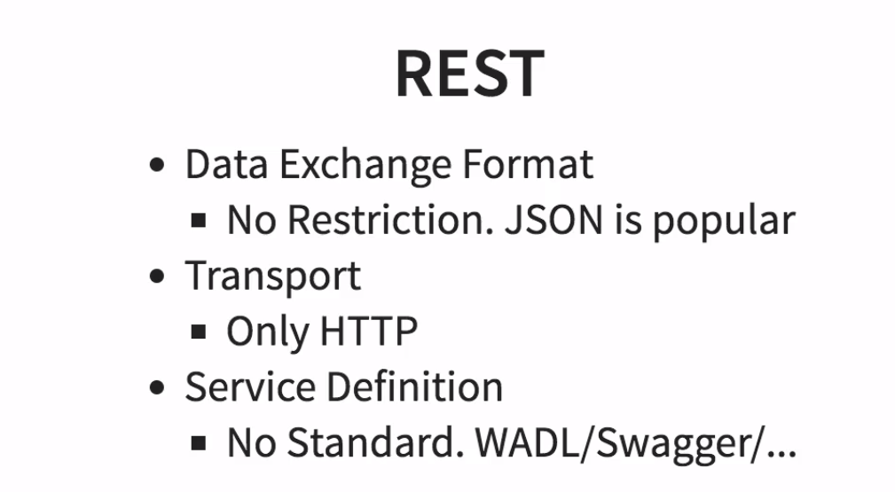

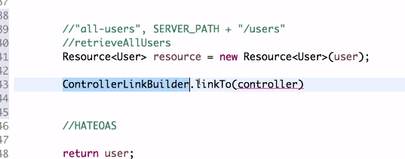

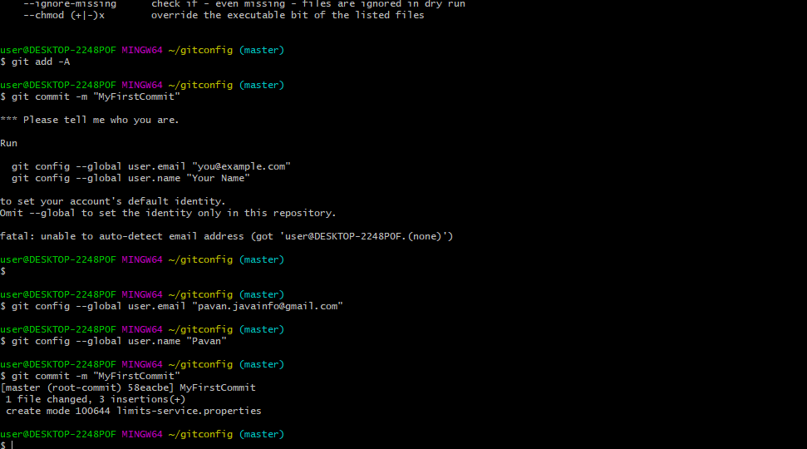

<https://github.com/in28minutes/in28minutes-initiatives/tree/master/The-in28Minutes-TroubleshootingGuide-And-FAQ#debugging-problems-with-spring-cloud-config-server>

<https://github.com/in28minutes/in28minutes-initiatives/tree/master/The-in28Minutes-TroubleshootingGuide-And-FAQ#debugging-problems-with-feign-and-ribbon>

<https://github.com/in28minutes/in28minutes-initiatives/tree/master/The-in28Minutes-TroubleshootingGuide-And-FAQ#debugging-problems-with-naming-server-eureka-and-ribbon>

<https://github.com/in28minutes/in28minutes-initiatives/tree/master/The-in28Minutes-TroubleshootingGuide-And-FAQ#debugging-problems-with-zuul-api-gateway>

<https://github.com/in28minutes/in28minutes-initiatives/tree/master/The-in28Minutes-TroubleshootingGuide-And-FAQ#debugging-problems-with-zipkin>

Hystrix dependency :

<https://github.com/spring-cloud/spring-cloud-netflix/blob/master/spring-cloud-netflix-hystrix/pom.xml>

<https://spring.io/blog/2019/10/25/spring-cloud-hoxton-rc1-released>